NDB Capital Holdings Donates Computers to Rural Schools

Sri Lanka’s premier Investment Bank, NDB Capital Holdings (NCAP) donated computer equipment to three under privileged schools. The subsidiaries of NCAP, NDB Investment Bank (NDBIB), NDB Wealth Management (NWM), and NDB Stockbrokers (NDBS) organized the donation of computers to Attaragama Kanishta Vidhyalaya in Harispattuwa, Migahajandura Maha Vidyalaya in Sooriyawewa, and J Keerimalai Naguleswarm Vidyalayam in Keerimalai. These schools were chosen based on the need for computer facilities and to represent all parts of the country and all communities.

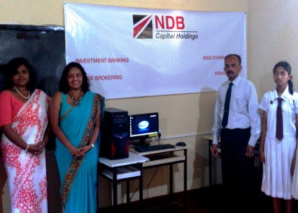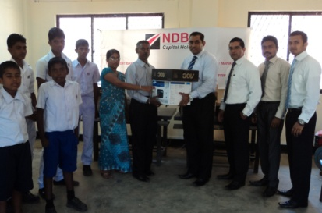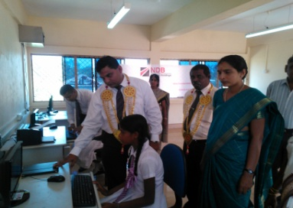

Attaragama Kanishta Vidhyalaya, Harispattuwa in Kandy district has 110 students. The school has IT as a subject for all the students from year 1 to 11, but lacked the computer facilities to conduct the classes. The Principal Major H.P. Mewantissa said that with the computers they received, the school is now able to conduct IT classes for the children.

Migahajandura Maha Vidyalaya, Sooriyawewa, in Hambantota district dates back to 1892 and has 564 students, 31 staff members, and classes from Grade 1 to 13. According to the principal Mr. Gamini Dahanayake, computer facilities were much needed for the school.

J Keerimalai Naguleswarm Vidyalayam, Keerimalai in Jaffana district was a displaced school for 22 years due to the war in the North and East. When the NDB Stock Brokers branch in Jaffna heard about the need for computers for this school through the acting principal, they immediately obliged.

According to CEO Vajira Kulatilaka, “NCAP is a knowledge based organization and whole-heartedly believes that education is the key to a prosperous society. Most of our professional staff have received the benefit of the Free Education System, and feel an urge to give something back to the society. Based on the belief that access to information and knowledge sharing promotes national harmony, we selected schools in Jaffna, Hambanthota, and Kandy to receive the donations. We sincerely hope that the students in these schools will embrace the opportunity they have been provided with.”

NDB Capital Holdings PLC is the only listed full-service investment bank in the country which offers fund and fee based investment banking services such as debt and equity raising, corporate advisory, mergers & acquisitions, stock broking, wealth management, private equity and underwriting. The fee based services are carried out via subsidiaries of NCAP, namely NDB Investment Bank, NDB Stockbrokers (Pvt) Ltd, and NDB Wealth Management Limited; whilst fund based activities are performed directly under the Company. NCAP is a subsidiary of NDB Bank PLC.

